**Smart India Hackathon 2023 - College Internal Report**

1. **About the event**

**Introduction**

The Smart India Hackathon (SIH) is an annual event organized by the Government of India to encourage innovation and problem-solving through technology. In line with the SIH guidelines, R.V.R & J.C College of Engineering successfully conducted an internal Hackathon titled “Smart Idea Challenge 2023” on September 15 and 16, 2023. This event aimed to foster creativity, teamwork, and technical expertise among the students while addressing real-world challenges faced by various sectors in India.

**Preparation and Planning**

Theme Selection:

The first step in organizing the Smart Idea Challenge 2023 was selecting relevant themes aligned with the SIH guidelines. After consultation with faculty members and industry experts, the following themes were chosen:

1. Smart Education

2. Med Tech / BioTech and Health Tech

3. Disaster Management

4. Agriculture, food tech and rural development

5. Smart Automation

6. Robotics and drones/ Smart vehicle

7. Clean and green energy/ Renewable Energy

8. Fitness and Sports

9. Block Chain & Cyber Security

10. Mobile Apps related to Culture & History

**Student Participation**

The event was promoted extensively among our students nand students are encouraged to submit ideas for the problems posted in SIH site, ie., from sih.gov.in. We received enthusiastic responses. Total 336 students registered to participate, forming **56 teams** with diverse skill sets, backgrounds, and expertise. This ensured a wide range of innovative solutions for the selected problem statements forthemes.

Problem Statements

Teams were given access to problem statements specific to each theme. These problem statements were sourced from SIH(sih.gov.in) and real-world challenges faced by government departments, industries, and non-governmental organizations. Each team chose one problem statement to work on.

The ideas were evaluated by faculty experts from the college and a total of **42 teams** were shortlisted for final presentation. The evaluation process is presented in Section 4.

1. **Photos of the event organized**

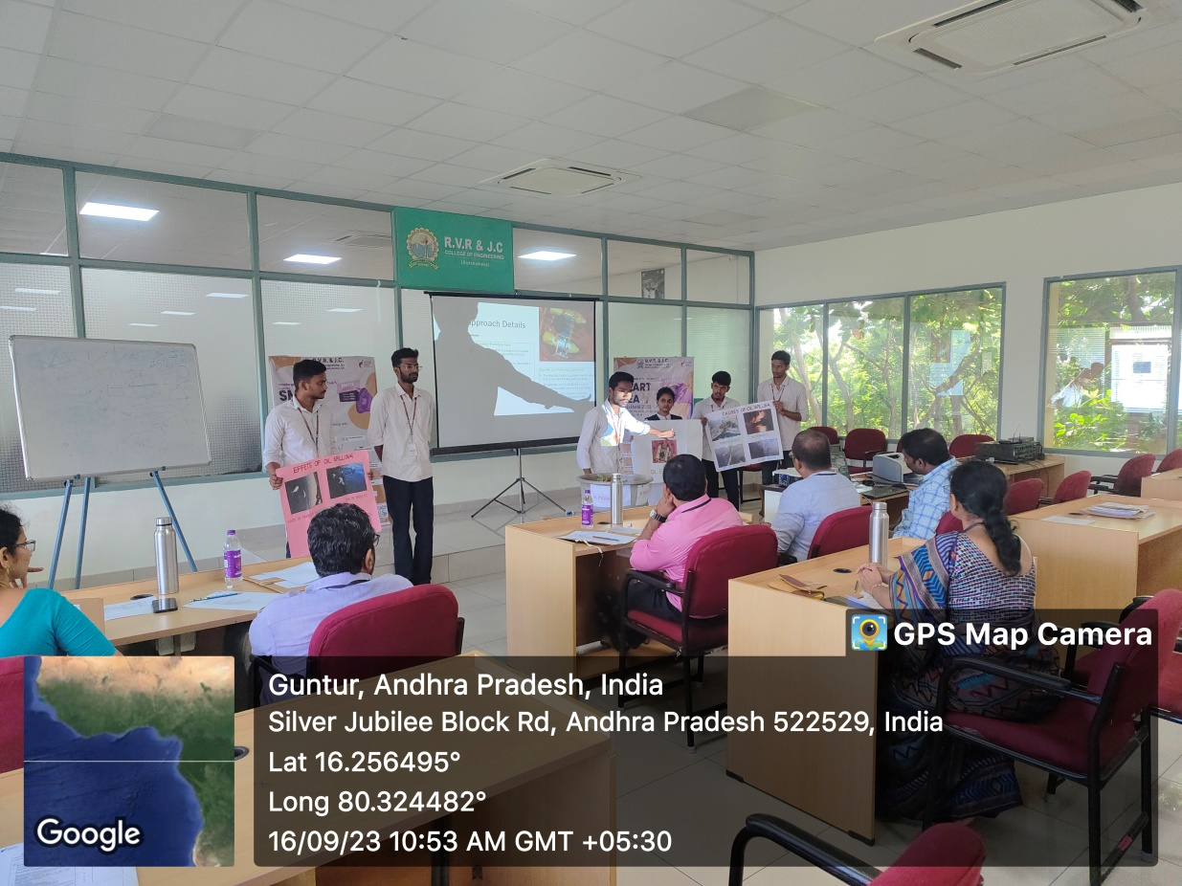

https://drive.google.com/drive/u/0/folders/1M5zUQlpV1PVw7_0JD9TZzkBy9rnGdKCx

**3. Pictures of all participating teams**

**4. Judging process**

The 42 participating teams were evaluated by three panels in parallel with each panel comprising three judges.

The first panel adjudged teams that were grouped under the following themes:

1. Med Tech / BioTech and Health Tech
2. Disaster Management
3. Clean and green energy/ Renewable Energy

The second panel adjudged teams that were grouped under the following themes:

1. Agriculture, food tech and rural development
2. Smart education
3. Travel and tourism

The third panel adjudged teams that were grouped under the following themes:

1. Smart Automation
2. Robotics and drones/ Smart vehicle
3. Fitness and Sports
4. Block Chain & Cyber Security
5. Mobile Apps related to Culture & History

Each panel of judges evaluated the solutions based on innovation, feasibility, impact, and presentation criteria. Each team presented their projects to the judges, highlighting the problem they addressed and the technology stack used. The following are the parameters on the basis of which the evaluation process was carried out.

|  |
| --- |
| **Novelty of the Idea** |
| **Complexity of the Idea** |
| **Clarity and Details of the Idea** |
| **Feasibility of solution** |
| **Measurable-** Whether **t**he proposed IDEA is measurable and step wise approach towards innovation is followed |
| **Attainable-** Clarity of team. Is the team competent enough to develop the solution and achieve its objectives? |
| **Time Line :** |
| **Practicability:** |
| **Applicability of Solution** |
| (a) Usability: Level of acceptance of Solution/Features among target group |
| (b) Scalability: Adoption Potential of Solution as Business Model/Startup |
| (c) Economic Sustainability: Potential of solution to Become profitable or financially viable |
| (d) Environment Sustainability: Potential of solution to become environment friendly or address environment problems |

The judging process was carried out in two rounds.

**Round 1:** The recommendations made by the three panels were analyzed and a total of 23 teams were nominated to take part in the Smart India Hackathon 2023.

**Round 2:** Of these 23 teams, 9 teams were selected for Round 2. These teams were allowed to present their ideas before a single panel of all 9 judges and the top three teams were awarded cash prizes.

**5. Nominated top teams**

After careful evaluation, a total of 24 teams were nominated for the Smart India Hackathon 2023.

|  |  |  |  |
| --- | --- | --- | --- |
| **S.No** | **TEAM NAME** | **THEME** | **Problem Statement** |
|  | Wizards (SI) | Smart education | website to bridge between the students and the industries |
|  | PsyCheck | Fitness and Sports | Self-identifying the mental health status and get guidance for support. |
|  | Aqu Therapy | Agriculture, food tech and rural development | Uncontrolled growth of water Hyacinth in lakes |
|  | Supersix | Blockchain & Cybersecurity | Design and Developed a personalized online meeting system for AICTE |
|  | SmartEdu | Smart education | Digital Assistant for legal awareness and designing a KYC framework in India |
|  | Alpha (SI) | Agriculture, FoodTech & Rural Development | Watering of plant using mobile |
|  | Infinite tsukuyomi (SI) | Clean and Green Energy/ Renewable Energy | Conversion of waste water to Electrical energy |
|  | Artificial hand (SI) | Med tech/biotech/health tech | Low cost prosthetic Artificial hand |
|  | Salinedrip Solutions (SI) | Med tech/biotech/health tech | Solution by creating a saline stand attached with a buzzer that gives a sound to remind to change the saline bottle |
|  | Gryffindors | Smart Automation | Centralized Monitoring System forStreet Light Fault Detection and Location Tracking |
|  | Cyber Automaters | Smart Automation | Centralized monitoring system for street light fault detection and location tracking. |
|  | MVMNML (SI) | Smart Automation | Automatic Theory Paper Corrector |
|  | Yatra(SI) | Travel & Tourism | Website to suggest visiting the nearest place |
|  | GrowXpert | Agriculture, food tech and rural development | App-Based Solution to identify and solve disease in plants/crops |
|  | Team Enviro Chem | Renewable / Sustainable Energy | Green options for packaging (Low cost, environment- friendly, and extended shelf life packaging for milk) |
|  | Artificer Crew | Transportation & logistics | A system of IoT Devices to prevent under-loading / overloading of Railway wagons. |
|  | Amphere | Med tech/biotech/health tech | Development of Technology for manufacturing of mind control BIONIC hand with a sense of touch |
|  | OptoScultpures (SI) | MISC/Technology ideas in Retail sector. | customized gift that uses lasers to display names |
|  | Cognicompass | Med tech/biotech/health tech | Computerized Cognitive Retraining Program for Home training of Children with Disabilities. |
|  | Titans (SI) | Smart Automation | Alcoholic Sensors And Eye Blinking Sensors |
|  | Team IDIOT | Disaster Management | Estimation of inflow to a reservoir from the rainfall considering soil moisture in its catchment and releases from upstream reservoirs and automatically opening of reservoir gates for moderately releasing the water to avoid the flooding in a basin. |
|  | Encrypted Titans (SI) | Smart Automation | A new application on speech synthesis during calls. |
|  | Vikram sarabhai (SI) | Disaster Management | OIL EVICTION MACHINE |

**6. Judges photos and details**

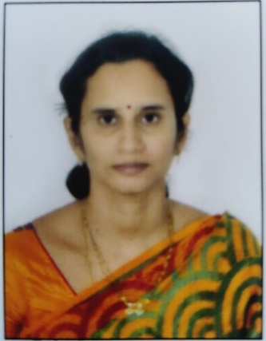**Panel 1**

**Dr. Lakshmi Tulasi**

Professor

Department of CSE

RVR&JC College of Engineering

[rltulasi.2002@gmail.com](mailto:rltulasi.2002@gmail.com)

+91 94408 23573

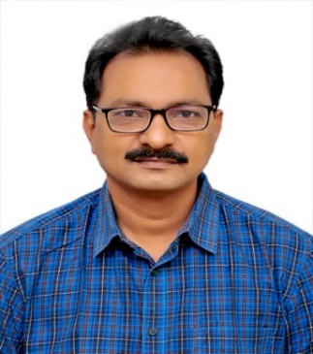**Dr J. Ravindranadh,**

Professor,

Department of ECE,

RVR&JC College of Engineering

jravindranadh@rvrjc.ac.in

+91 9885263004

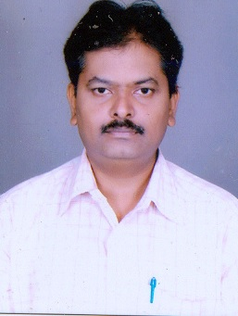**Dr. A. Sri Nagesh,**

Professor,

Department of CSE,

RVR&JC College of Engineering

srinagesh@rvrjc.ac.in

9849243969

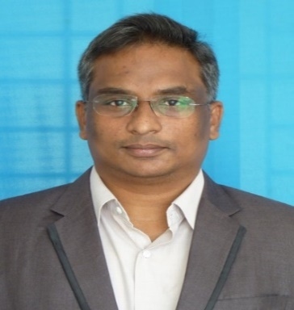**Panel 2**

**Dr P. Suresh Kumar,**

Assoc. Professor,

Department of ECE,

RVR&JC College of Engineering

psureshkumar@rvrjc.ac.in

+91 9866607690

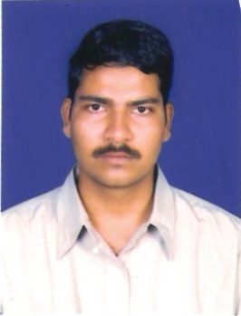**Dr. C. Tara Sasanka,**

Assoc. Prof.

Department of ME

RVR&JC College of Engineering

[tarasasankac@gmail.com](mailto:tarasasankac@gmail.com)

+91 99664 31000

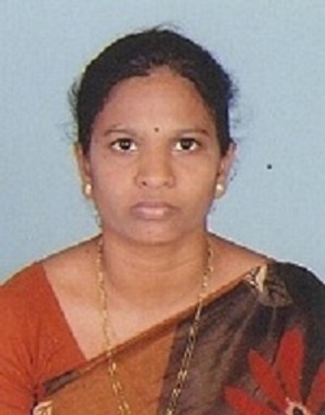**Dr. Ch. Suneetha,**

Professor

Department of MCA

RVR&JC College of Engineering

suneethachittineni@gmail.com

+91 9704118784

**Panel 3**

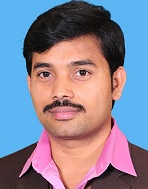

**Dr. Alla Rama Koteswara Rao,**

Associate Professor,

Department of EEE,

RVR&JC College of Engineering

ramnitkkr@gmail.com

+91 9034184518

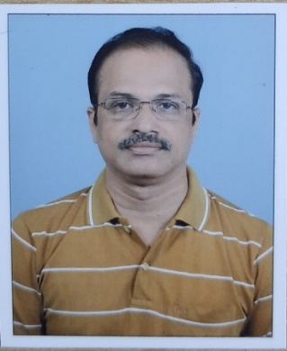**Dr. M. Murali,**

Associate Professor,

Department of Chemistry

RVR&JC College of Engineering

murali.musuluri@gmail.com

+91 7382323007

**8. Total teams and students participated and photos**

**9. News article if any**

**10. Twitter/FB/LinkedIn link for the event organized and promoted on your social media**

**Facebook:**

<https://www.facebook.com/100057410021726/posts/pfbid02h38acyRXppHoG916sXpfu7B16m2eYCiERowQksSYj3cTkPxq3GgBTdL5a7QbzUVel/?mibextid=Na33Lf>

**Linkedin:**

[https://www.linkedin.com/posts/r%2Ev%2Er%2E-%26-j%2Ec%2E-college-of-engineering_rvrjcce-students-hackathon-activity-7105589244131213312-iArn?utm_source=share&utm_medium=member_ios](https://www.linkedin.com/posts/r.v.r.-%26-j.c.-college-of-engineering_rvrjcce-students-hackathon-activity-7105589244131213312-iArn?utm_source=share&utm_medium=member_ios)

**X(Twitter):**

<https://x.com/rvrjc_official/status/1699827004399579563?s=46&t=uYkOswZBhJT1pSucJaR4DA>

**Conclusion**

The internal Smart India Hackathon, “Smart Idea Challenge 2023”, conducted in our college on September 15, 2023, was a resounding success. It not only provided a platform for students to showcase their technical skills but also offered practical solutions to real challenges faced by different sectors in India. We believe that such events are instrumental in nurturing innovation and fostering a culture of problem-solving among the youth. We look forward to participating in future Smart India Hackathons and continuing to contribute to the nation's progress through technology-driven solutions.